Team 2’s Wiki

# Introduction

Member:

1. Trần Nguyên Tiến Sứ

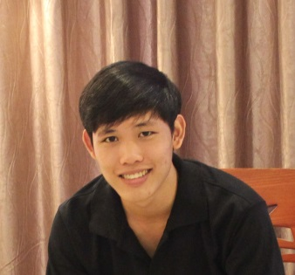

*Java developer, 22yrs*

*Love football and travel a lot*

*Read books when have free time*

1. Trần Cao Danh



*22yrs*

*Love football, food and research everything.*

1. Trương Hải Đăng

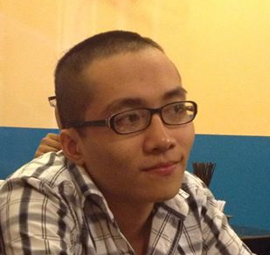

*Love football, food and research everything with my friends.*

1. Bùi Nguyên Tín

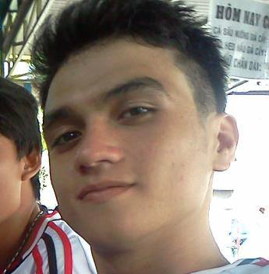

*[Type a quote from the document or the summary of an interesting point. You can position the text box anywhere in the document. Use the Drawing Tools tab to change the formatting of the pull quote text box.]*

# Capstone Project’s Agreement

1. Communication tool:

* Skype
* Su’s skype: trannguyentiensu (online minimum 12hours/day)

1. Timesheet link:

<https://docs.google.com/spreadsheets/d/1Kbx3ekKQrxg7vxcLjCtjXL6fUrGwH_mfp4iUH9davhQ/edit?usp=sharing>

1. Daily meeting:

* Conduct at 10:30pm at every evening.
* Each member talk about: *“What I have done today?”, “What the difficulties I meet?”, “What I will do in next day?”.*

1. Team meeting:

* Weekly at 15pm Tuesday

1. Task receive:

* Try to finish by yourselves
* If meet difficult, discuss with team to find solution.

1. SVN:

* SVN checkout link: https://online-medical-consultant-system.googlecode.com/svn/trunk/ online-medical-consultant-system
* Convention when commit:

[Task] - Description

1. Group discussion:

<https://groups.google.com/forum/#!forum/online-medical-consultant-system>

# OMCS Project

1. After get OMCS from SVN, follow this link to make a successful build.
2. Edit **connectionStrings** from OMCS\ApplicationWeb\Web.config as your configuration
3. Template demo: localhost:port/Template
4. Login link: localhost:port/Account/Login
5. Admin: admin

Pass: 123456

1. User: user1

Pass: 123456